I. INTRODUCTION

The purpose of the guide is to provide an overview of stormwater terms and the Fairfax County requirements associated with the management of stormwater. In addition, this guide provides information on how county stormwater requirements are adopted and how they are enforced.

Stormwater runoff is rain or snowmelt that runs off the land surface. As communities develop, more impervious land surfaces (e.g. roads, driveways, patios, rooftops, etc.) are created and less rainfall can soak into the ground or be intercepted by vegetation. Although it is recognized that development is a necessity for a community’s economic and social viability, the additional stormwater runoff created by development can have detrimental effects on the land, man-made structures, streams, rivers and eventually the Chesapeake Bay, due to increases in pollutants, soil erosion, stream bank and bed erosion, and flooding. County stormwater requirements were established and are enforced to minimize these impacts.

The stormwater requirements only address permanent stormwater treatment and conveyance measures left in place after construction is completed. The county’s erosion and sediment control requirements, which address temporary stormwater control and conveyance measures, will not be covered in this guide. Once the construction is complete and the site is stabilized, the erosion and sediment control facilities are removed. Readers interested in an overview of erosion and sediment control practices should consult the Virginia Erosion and Sediment Control Handbook (http://www.dcr.virginia.gov/soil_&_water/e&s-ftp.shtml).

This guide is an overview of the county’s stormwater requirements and is not intended to provide design guidance or cover all aspects of existing ordinance requirements, and design and construction standards. Readers interested in reviewing the county ordinance provisions and the design and construction standards that are the basis of the stormwater requirements presented in this guide are referred to Chapter 6 of the Public Facilities Manual (PFM), and Chapters 101 (Subdivision Ordinance), 112 (Zoning Ordinance) and 118 (Chesapeake Bay Preservation Ordinance) of the County Code. Engineers and other land development professionals use the PFM as guidance for developing in Fairfax County. The PFM sets forth the guidelines which govern the design of all public facilities constructed to serve a new development.

The remainder of the guide is organized as follows:

Section II – How County Stormwater Requirements Are Adopted – This section describes the process by which any amendments are made to the existing stormwater requirements, including public hearings and the political entities involved in the adoption of the amendments.

Section III – The Stormwater Requirements – This section describes the requirements and elaborates on terms and concepts associated with the requirements.

Section IV – How the County Stormwater Requirements Are Enforced – This section describes the steps the county takes to ensure compliance with the requirements.

II. HOW COUNTY STORMWATER REQUIREMENTS ARE ADOPTED

Local jurisdictions in the Commonwealth of Virginia, including Fairfax County, have only those powers that are granted to them by the state. The county does not have the ability to simply enact whatever requirements it chooses. All county stormwater requirements are based on provisions of the State Code and associated regulations that allow or require the enactment of local requirements. The request for amendments to existing county requirements may originate because of one of the following:

- New state mandates (may be based on new federal mandates);
- Changes in technology; or
- Requests from the public, residents, the Board of Supervisors, or county agencies.

The proposed amendments to existing county stormwater requirements typically are prepared by Department of Public Works and Environmental Services (DPWES) staff in coordination with other county agencies as needed to ensure that they comply with state regulations, reflect sound engineering and environmental practice, and do not conflict with other existing county requirements and policies.

The changes may affect several county ordinances and regulations, including the PFM, the Subdivision Ordinance, the Erosion and Sedimentation Control Ordinance, the Zoning Ordinance, and the Chesapeake Bay Preservation Ordinance.

Amendments to the County Code or the PFM are presented to the Board of Supervisors (Board) and require the Board’s adoption prior to becoming a county requirement. The Board is a political body, which is elected by the residents of the county. The Board consists of nine members elected by district, plus a chairman elected at large.

The Planning Commission advises the Board on all matters related to the orderly growth and development of the county. Planning Commission members are appointed by the Board. Any amendments, which affect land development, are reviewed by the Planning Commission, as well as the Board.

The Board of Supervisors also appointed members to the Engineering Standards Review Committee (ESRC) to provide recommendations regarding proposed amendments to the PFM. The ESRC consists of representatives from community groups, the development industry, the engineering community, residents of Fairfax County, Fairfax County Park Authority, Fairfax County Department of Planning and Zoning, and Virginia Department of Transportation. All proposed PFM amendments are presented to the ESRC.

Consideration of proposed amendments by the Planning Commission and the Board of Supervisors occur through a public hearing process, which gives interested parties the opportunity to voice their concerns or support regarding the amendment. The first public hearing, which is before the Planning Commission, is advertised in a local newspaper prior to the hearing. Anyone wishing to speak regarding the amendment may do so at the public hearing. Written comments may also be submitted. Subsequent to the first public hearing, the Planning Commission votes on its recommendations to the Board of Supervisors. This information is forwarded to the Board of Supervisors prior to the public hearing before the Board of Supervisors.

The second public hearing, which is before the Board of Supervisors, is then advertised in a local newspaper prior to the hearing. Again, anyone wishing to voice his or her concerns or support for the amendment may do so at the public hearing. Written comments may also be submitted. Subsequent to the second public hearing, the Board of Supervisors votes on whether or not to adopt the amendment. Prior to adoption, the Board may make changes to the proposed amendment within the scope of what was advertised.

Once the Board has adopted an amendment with an effective date, the language of the new requirement is incorporated into the affected documents.

III. THE STORMWATER REQUIREMENTS

Fairfax County stormwater requirements promote a safe environment, protect and conserve the water resources of the county, and provide for the adequate drainage of surface waters by addressing the following:

- Quantity of stormwater runoff leaving a site after construction is complete (including the effective conveyance of stormwater through and from the site);
- Quality of stormwater runoff leaving a site after construction is complete;
- Potential impacts to downstream systems and properties;
- Drainage diversions; and
- Floodplains

In order to understand the stormwater requirements, there are several general terms and concepts, which must be established.

A rainfall event can be described using the following terms:

- Duration – The length of time (hours) over which the precipitation occurs.
- Depth – The total amount of precipitation (inches) occurring for the duration of the storm. In this context, depth is sometimes used interchangeably with volume although it is not strictly speaking a volume measurement.
- Frequency – The recurrence interval of storm events having the same duration and volume. Frequency can be expressed as a return period or an exceedance probability. The return period is the average length of time between events having the same volume and duration (e.g. 10-year 2-hour storm). An exceedance probability is the probability that an event having a specified volume and duration will be exceeded in a one year period (e.g. a 100-year storm has a 1% probability of occurring in any given year)].
- Intensity – The depth divided by the duration (inches per hour). Intensity may be computed for the entire storm duration or for specified time increments within a storm.

There are several methods for quantifying the volume (cubic feet) and peak discharge rate (cubic feet per second) that will occur at a specified location in a channel, pipe or other conveyance during a particular rainfall event. All of these methods require certain information, including the following:

- Design storm – A design storm is based on a statistical rainfall event with a certain frequency and duration (e.g. 10-year, 24-hour storm).
- Drainage area – An area of land that contributes stormwater runoff to a designated point.
- Amount of impervious area – Impervious area includes surfaces such as parking lots and rooftops. Such surfaces do not allow water to infiltrate into the ground and result in more of the rainfall becoming stormwater runoff after the land has been developed.
- Time of concentration – Time of concentration is the amount of time required for stormwater to flow from the most remote point of a drainage area to the outlet or point of interest. Time of concentration is based on the topography of the land within the drainage area, the shape of the drainage area, the type of surface over which the stormwater flows, and the path the stormwater takes to reach a given point.
- Pre-development condition – Reflects the topography and features at the site prior to the proposed development
- Post-development condition – Reflects the topography and features at the site proposed by the development

A. STORMWATER REQUIREMENTS REGARDING QUANTITY OF STORMWATER RUNOFF

Overland Relief for the 100-year Storm (§§ 6-0101 and 6-1500 of the PFM)

The drainage system can be divided into two parts, the minor drainage system and the major drainage system. The minor drainage system is normally designed for the 10-year storm frequency and consists of storm drain appurtenances and conduits such as inlets, manholes, street gutters, roadside ditches, swales, small underground pipes and small channels, which collect the stormwater runoff and transport it to the major system. The major drainage system is designed for less frequent storms (up to 100-year storm frequency) and consists of natural waterways, large man-made conduits, and large water impoundments. The major system includes some less obvious drainageways such as overland relief swales and infrequent temporary ponding at storm drain appurtenances. The major system includes not only the trunk line system which receives the stormwater from the minor system, but also the natural backup system which functions in case of overflow from or failure of the minor system. This back up system is called overland relief and provides a path for stormwater to ensure that buildings are not flooded during a 100-year storm even if the minor drainage system is blocked.

Detention Requirements (§§ 6-0300 and 6-1300 of the PFM)

Detention of stormwater is required for any land development that increases the amount of impervious area on a development site with one exception. Detention is not required for individual residential lots being developed in previously created subdivisions. The basic requirement is that the 2-year, 2-hour design storm and the 10-year, 2-hour design storm must be detained at the development site such that the peak discharge rate is at or below the peak discharge rate prior to development. The stormwater runoff may be detained using facilities such as ponds (either dry or wet ponds), underground storage chambers (for commercial facilities only), rooftop storage, percolation trenches, and pervious pavement with underground storage, and bioretention with underground storage. Design standards and the required calculations for detention facilities are outlined in the PFM. Detention facilities that serve residential areas must be located in HOA “common” areas and may not be located on individual buildable residential lots. Dry ponds in residential areas and some types of regional facilities are maintained by the county and are placed in storm drainage easements. All other detention facilities are privately maintained. The Virginia Department of Transportation (VDOT) maintains detention facilities associated with its road system.

Stormwater Pipe, Inlet and Open Channel Design (§§ 6-0900, 6-1000, 6-1100, and 6-1200 of the PFM)

Manmade drainage facilities are constructed systems which convey stormwater and may include culverts under roads, storm drain pipe, inlets, manholes, roadside ditches and open channels. The PFM and VDOT Drainage Manual provide guidance for the design of manmade drainage facilities. The guidance establishes the design storm for a given situation and the methods that are used to determine the peak flow rates and water surface elevations in the stormwater drainage system. The most commonly required design storm for the conveyance elements of the system is the 10-year storm. Larger design storms are used for culverts under major roadways or when overland relief cannot be provided.

Some stream restoration projects use what is referred to as natural channel design concepts as a basis for design. Natural channel design uses an engineering analysis based on fluvial geomorphic processes (e.g. meandering and removal and deposition of sediment) to create, rehabilitate, restore, or stabilize an open conveyance system for the purpose of creating or recreating a stream. Streams designed by this method typically have a meandering pattern and require more space to construct.

Maintenance responsibility for manmade drainage facilities depends upon their purpose. If the facility is located in a VDOT-maintained road right-of-way, VDOT will maintain the facility. If the facility is collecting and removing stormwater from a private commercial or institutional development, the facility will be privately maintained. If the facility accepts drainage from an upstream property, or serves residential development, the county will maintain the facility. All county-maintained facilities are located in storm drainage easements.

B. STORMWATER REQUIREMENTS REGARDING THE QUALITY OF STORMWATER RUNOFF

What is placed in the storm drain system eventually makes its way to our local streams, rivers, the Chesapeake Bay and eventually the ocean. It may be tempting to think that the philosophy “out of sight, out of mind” works when one washes used oil or antifreeze down into the storm drain system. However, any pollutants such as used oil or antifreeze, that are discharged into the storm drain system will make their way into our stream system and cause environmental damage. Therefore, in order to protect the streams in the county, our drinking water supply, the Potomac River, and the Chesapeake Bay, it is illegal to discharge certain potential pollutants into the storm drain system. Chapter 106 of the County Code states that it is unlawful for any person to deposit or cause to be deposited, in any public storm drainage facility, including gutters and ditches, any substance, included but not limited to, trash, grass clippings, petroleum products, or other noxious or flammable substance.

Phosphorus is a nutrient for algal growth in rivers, the Occoquan Reservoir, and the Chesapeake Bay, and consequently is used as the indicator pollutant for nonpoint source pollution. The more phosphorus there is in the stormwater, the more algal growth in rivers and the Chesapeake Bay. This algal growth causes an oxygen-depleted environment in waterways that is detrimental to aquatic life. In order to protect the quality of stormwater runoff, the stormwater requirements require reductions in phosphorus from development sites. Water quality facilities that remove phosphorus will also remove other nonpoint source pollutants in stormwater.

Occoquan Reservoir (§ 6-0401.1 of the PFM)

The area that drains to the Occoquan Reservoir has been designated as a Water Supply Protection Overlay District (WSPOD) under the Zoning Ordinance in order to prevent water quality degradation of the reservoir due to pollutant loadings. The projected phosphorus loadings for any development in the WSPOD must be reduced by at least one-half for any subdivision or use requiring site plan approval.

Chesapeake Bay Preservation Ordinance (§ 6-0401.2 of the PFM)

In order to protect the quality of water in the Chesapeake Bay and its tributaries, including our local streams, Chesapeake Bay Preservation Areas have been established throughout the entire county. The Chesapeake Bay Preservation Areas consist of Resource Protection Areas (RPAs) and Resource Management Areas (RMAs). RMAs make up the majority of the county. The remainder of the area is RPAs, which are located around perennial streams, are considered more sensitive areas and are subject to more restrictive requirements regarding development. The more restrictive regulations are outlined in Chapter 118 (Chesapeake Bay Preservation Ordinance) of the County Code and § 6-1700 of the PFM. RPAs are delineated on Fairfax County Chesapeake Bay maps, which can be found at www.fairfaxcounty.gov/gisapps/pdfViewer/default.htm.

Requirements pertaining to RPAs and RMAs are outlined in Chapter 118 of the County Code (Chesapeake Bay Preservation Ordinance); further guidance on RPAs and RMAs is provided in § 6-1700 of the PFM.

For new development outside of WSPOD, the projected phosphorus loading from a proposed development must be reduced by no less than 40%. The requirement does not pertain to any development that does not require a site plan submittal, that does not require subdivision approval, and that does not result in impervious cover of 18% or greater on the lot or parcel on which the development will occur. For redevelopment, the phosphorus removal is established by a formula described in § 6-401.2B, and C of the PFM. Redevelopment must meet the terms established in § 6-401.2D of the PFM to be considered as a redevelopment.

Best Management Practices (BMPS) (§ 6-0402 of the PFM)

In order to achieve the level of phosphorus removal required by the Chesapeake Bay Preservation Ordinance and WSPOD requirements, the developer must provide treatment facilities on the site, which is generally the case; or discharge into an offsite facility that is capable of removing phosphorus from the stormwater runoff. Facilities used to remove phosphorus from stormwater are called Best Management Practices (BMPs). Guidance on the design of BMPs can be found in the PFM and the Northern Virginia BMP Handbook (http://www.novaregion.org/pdf/NVBMP-Handbook.pdf). The types of BMPs accepted by the county and their associated phosphorus removal efficiencies are listed in the PFM. The PFM also provides for the use of innovative BMPs on a case specific basis subject to the submission of performance data demonstrating efficacy and certain restrictions designed to address maintenance considerations. BMPs include, but are not limited to the following: extended detention dry ponds, wet ponds, infiltration trenches, sand filters, pervious pavement, bioretention facilities (rain gardens), and vegetated roofs (green roofs).

C. PROVISIONS FOR ADEQUATE DRAINAGE (POTENTIAL IMPACTS TO DOWNSTREAM SYSTEMS AND PROPERTIES)

Stormwater runoff leaving a development site may be described as non-concentrated or concentrated. Non-concentrated stormwater runoff is shallow water flowing overland from the point where stormwater runoff begins and prior to a well-defined channel or conveyance system (See Appendix B for a more detailed definition). Concentrated stormwater runoff is stormwater flowing in a relatively narrow, confined manner, either in a natural or man-made channel or conveyance system. The points where concentrated flow leaves a development site are referred to as the site’s outfalls. The requirements are based on what type of stormwater runoff is exiting the development site.

Non-concentrated Stormwater Runoff (§ 6-0202.6 of the PFM)

When non-concentrated stormwater runoff is leaving the development site, it must be shown that:

- The post-development peak discharge rate does not exceed the predevelopment peak discharge rate, or
- The increase in peak discharge rates and volumes caused by the development will not have any adverse impact on the lower lying property.

Adverse impact is considered to be aggravation of an existing condition or creation of a condition that causes damage to property through soil erosion, sedimentation, duration of ponding water or flooding of buildings, which are constructed under an approved building permit, or of any dwellings. However, if the adverse impact is caused by the lower lying property owner obstructing drainage (e.g. filling in an existing channel to get a flatter yard, installing an undersized culvert under a driveway), the developer is not held responsible for the adverse impact. As stated in Section 2-602, Paragraph 1 of the Zoning Ordinance, obstructions to drainage are not allowed.

Concentrated Stormwater Runoff (§§ 6-0202.3 and 6-0203 of the PFM)

Where concentrated stormwater runoff leaves the development site, the required analysis is much more extensive. The first step is to establish how far downstream from the development site, the receiving drainage system must be analyzed.

Extent of the downstream drainage system review (§6-0203.2 of the PFM)

The review of the downstream drainage system must be to one of the following three points:

- to a point that is at least 150 feet downstream of a point where the receiving pipe or channel is joined by another that has a drainage area that is at least 90% of the size of the first drainage area at the point of confluence (See Figure III-1) ; or

- to a point at which the total drainage area is at least 100 times greater than the contributing drainage area of the site (see Figure III-2); or

- to a point that is at least 150 feet downstream of a point where the drainage area is 360 acres or greater.

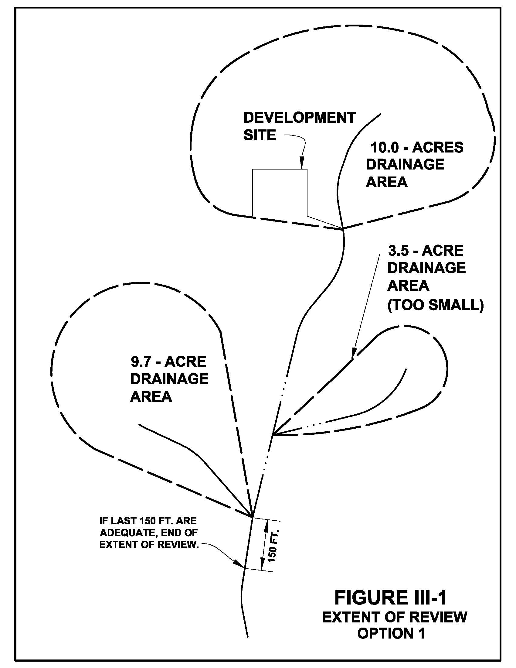
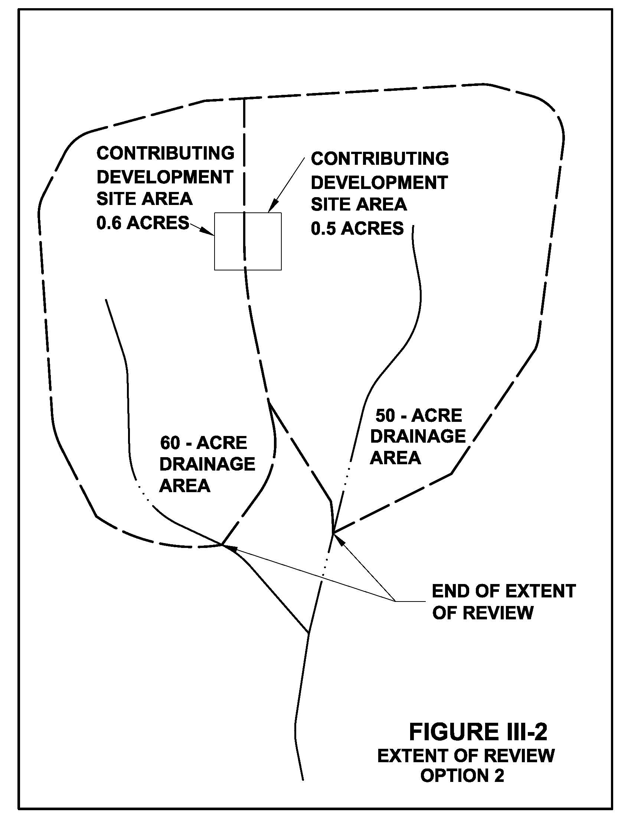
As you can see from Figure III-2, stormwater runoff from a site may go in different directions. Each outfall must be analyzed separately and may have a different extent of review. It should be noted here that if points 1 or 3 are used, the most downstream 150 feet must be adequate or the analysis must extend farther downstream until a 150-foot segment is reached that is adequate. The determination of adequacy is defined later in this guide.

The engineer must establish cross sections of the drainage system at points along the drainage system from the site to the end of the extent of review. For natural or man-made channels, cross-sections which are representative of the channel segment’s geometry are used in the analysis. Cross-section selection and information is based on Chapter 5 of the Virginia Erosion and Sediment Control Handbook, which is titled “Determination of Adequate Channel.”

It must be shown throughout the entire extent of review that the receiving channel is adequate, or it must be shown that the development will not adversely impact the receiving system and the condition of the receiving system will be proportionally improved. It must also be shown that the drainage system throughout the extent of review is either a natural watercourse or a man-made drainage facility. A natural watercourse is a defined channel that has bed and banks or, if the area is relatively flat (slopes of 2% or less), that may be a braided channel with multiple flow paths. The banks of a watercourse are perceptible side walls of the channel which serve to confine moving water. The bed is the bottom of the channel.

Adequacy (§ 6-0203.3 of the PFM)

Adequacy of a channel is based on the bank full capacity of the channel and the potential for erosion of the channel bed and banks. The channel cross-sections are checked for overtopping of the channel banks (inadequate capacity) and erosive velocities for the design storm. The term “overtopping the banks” means that the stormwater fills the channel and spills over the top of the banks. Erosion will occur at a cross-section if the peak velocity during the design storm is greater than the permissible velocity. The permissible velocity, which is the highest velocity that can occur without causing erosion, is based on the soil type and lining (e.g. grass or cobblestone) at the cross-section. Since erosion is not a concern in a pipe system, the adequacy of a pipe system is determine only by its capacity.

Adequacy can be shown at each of the cross-sections by meeting one of the following criteria:

- The total drainage area to the point of analysis is 100 times greater than the contributing drainage area of the development site;
- Stormwater runoff will not overtop the banks or cause erosion during a 2-year storm at cross-sections in a natural watercourse;
- Stormwater runoff will not overtop the banks during a 10-year storm or cause erosion during a 2-year storm at channel cross-sections in a man-made channel;
- Pipes, storm drain systems and culverts, which are not maintained by the VDOT, must have the capacity to convey a 10-year storm; and

- Pipes, storm drain systems and culverts, which are maintained by VDOT, must have the capacity to convey a 10-year storm or one of greater frequency. The design storm for VDOT-maintained systems is established in the VDOT Drainage Manual depending on the type of road the drainage is crossing under and whether or not overland relief has been provided.

More detailed guidance for the analysis for adequacy of channels is outlined in Chapter 5 of the Virginia Erosion and Sediment Control Handbook under the section titled “Determination of Adequate Channel.”

If some of the cross-sections are found to be inadequate, the downstream receiving system must be improved to provide adequacy or the engineer must show that the development does not have an adverse impact on the receiving system and provide proportional improvement regarding the inadequacy.

No Adverse Impact and Proportional Improvement (§ 6-0203.4 of the PFM)

There are three methods, which are detailed in the PFM, to show no adverse impact and proportional improvement. These methods are the Critical Shear Stress Method, the Channel Capacity Method and the Detention Method.

Critical Shear Stress Method (§ 6-0203.4A of the PFM)

The Critical Shear Stress Method may only be used if the cross-section is inadequate due to erosive velocity (peak velocity is greater than the permissible velocity during a 2-year storm). Shear stress is a measure of the force applied to the channel walls by the stormwater runoff. In this method, the shear stress during the specified design storm is compared to the permissible shear stress. Permissible shear stress is the point where the force applied to the channel walls begins to cause erosion. Permissible shear stress is based on soil type. Erosive work is the shear stress in excess of the permissible shear stress multiplied by the time over which the excess occurs. Enough detention must be provided at the development site, to keep the erosive work throughout the duration of the 2-year storm below the amount of erosive work that was occurring prior to development. The erosive work must be less than the pre-development condition by an amount called proportional improvement.

Proportional improvement is based on the development site’s proportional contribution of stormwater runoff to the total stormwater runoff for the drainage area at the cross-section where the inadequacy occurs. The proportional improvement can be expressed by the following formula:

P_{i} = [C_{d} A_{d}/ C_{cs} A_{cs}] x 100 where,

P_{i} = Required Proportional Improvement Below the Pre-Development Condition (%)
C_{d} = Runoff Coefficient for the Contributing Drainage Area of the Site after Development
A_{d} = Contributing Drainage Area of the Site (acres)
C_{cs} = Runoff Coefficient for the Contributing Drainage Area to the Cross-Section in an Existing Development Condition
A_{cs}= Contributing Drainage Area to the Cross-Section (acres)

Channel Capacity Method (§ 6-0203.4B of the PFM)

The Channel Capacity Method may only be used if the cross-section is inadequate due to overtopping of the channel banks during the specified design storm (2-year storm for natural watercourses and 10-year storm for man-made channels) or lack of capacity in pipe systems during the specified design storm.

For this method, it must be determined what size storm causes the channel to overtop or the pipe to reach capacity. This storm is called the overtopping storm. Enough detention must be provided at the development site so that the overtopping storm, as well as the 2-year and the 10-year storms, must be reduced to a level below the pre-development condition by a percent equal to the proportional improvement described above.

Detention Method (§ 6-0203.4C of the PFM)

The Detention Method differs from the Critical Shear Stress Method and the Channel Capacity Method in that all of the analysis is based on the site rather than the inadequate cross-section and that the Detention Method can be used for cross-sections that are inadequate due to erosion and/or overtopping. In fact, the Detention Method can be used in lieu of analyzing cross-sections for adequacy. It still must be shown that there is an existing natural watercourse or man-made drainage facility for the entire extent of the required downstream review.

The Detention Method requires that enough detention be provided at the development site to achieve the following:

- The 1-year storm volume must be detained for a minimum of 24 hours.
- The 2-year and 10-year post-development peak flow rates must be reduced below the respective peak flow rate under a good forested condition (simulates the site prior to any development). The good forested condition is a term used in the NRCS (Natural Resources Conservation Service) hydrology to mean a cover type of “woods” and a hydrologic condition of “good”.

The reduction of the 2-year and 10-year post-development peak flow rates results in a proportional improvement and is computed as follows:

R_{i} = [1-(V_{f}/V_{d}) X 100 where,

R_{i} = Reduction of Peak Flow Below a Good Forested Condition (%)
V_{f} = Runoff Volume from the Site in a Good Forested Condition
V_{d} = Runoff Volume from the Site in a Post-development Condition

Flooding (§§ 6-0202.4 and 6-0203.5 of the PFM)

Stormwater runoff leaving a development site may not aggravate or create a condition where an existing dwelling or a building constructed under an approved building permit floods from storms less than or equal to the 100-year storm.

If the condition already exists, it must be shown that the condition is not aggravated and is proportionally improved by the development. The 100-year storm must be detained at the site to less than pre-development conditions by an amount equal to the proportional improvement. The proportional improvement amount is the same as that used in the Critical Shear Method and the Channel Capacity Method.

D. DRAINAGE DIVERSIONS (§6-0202.2A of the PFM)

In order to understand drainage diversion requirements, the following terms must be defined:

- Drainage Area – An area of land that contributes stormwater runoff to a designated point
- Drainage Divide - The line of highest elevations (ridge line) that separates one drainage area from another
- Watershed - A defined land area drained by a river, stream, or drainage way, or a system of connecting rivers, streams, or drainage ways such that all surface water within the area flows through a specified point; basically, a watershed is a large drainage area.

Drainage diversions are physical alterations that affect the size of drainage areas. Stormwater runoff, which was flowing in one drainage area, is diverted to an adjacent drainage area. Not all alterations to the topography of the development site result in drainage diversions. As long as the same size of drainage area continues to leave the development site in the same direction, it is not considered a drainage diversion.

Drainage diversions are acceptable under certain conditions. The increase or decrease in discharge rates, volumes and durations of stormwater runoff leaving the development site due to the diverted flow may not have an adverse impact on adjacent or downstream properties. The drainage diversion must result in one of the following benefits:

- Improve an existing or potentially inadequate outfall condition;
- Preserve significant naturally vegetated area or save healthy, mature trees, which otherwise could not be preserved or saved;
- Maximize the water quality control and/or water quantity control provided;
- Address constraints imposed by the dimensions or topography of the site to preclude adverse impacts from steep slopes and/or runoff; or
- Minimize to a reasonable extent, as determined by county staff, the number of on-site stormwater management facilities.

The outfall analysis must be extended to the point where the diverted flow is returned to its natural watercourse, if it is beyond the extent of review described earlier. The only exception to this requirement is if the development is on a lot for a single family detached residence that is proposing a diversion of less than 0.5 cubic feet per second (cfs) during a 10-year storm.

A drainage diversion is not allowed if it adversely impacts the adequacy of downstream drainage systems; creates new floodplain areas on adjacent or downstream properties; alters Resource Protection Area boundaries; aggravates or creates non-compliance regarding floodplain requirements (see Section E below); changes the drainage area at points where perennial streams begin; or changes the total drainage area of a watershed depicted on the county map of watersheds, as may be amended.

E. FLOODPLAINS

What may be done in a floodplain (§ 6-0700 of the PFM)

The county regulates what may be done in a floodplain to provide for safety from floods, preserve the hydraulic and flood-carrying capacity of the floodplain, and to preserve the natural environment. The PFM and Chapter 112 of the County Code (Zoning Ordinance) include provisions regarding floodplains and permitted uses in floodplains. Floodplains are areas that are inundated during a 100-year storm and have a drainage area greater than 70 acres. Floodplains are classified as major or minor depending on the drainage area. Major floodplains have drainage areas equal to or greater than 360 acres. Not all floodplains in the county have been mapped and floodplain limits may need to be determined during the land development process.

All newly proposed subdivision lots must include sufficient land area outside of the 100-year floodplain to construct a residence. If it is a cluster subdivision, no portion of the clustered lots may be in the floodplain.

Every proposed residence must be located such that it is 15 feet away from the 100-year flood level and the lowest part of the lowest floor, including basements, is 18 inches above the 100-year flood level.

Proposed uses in the floodplain must be approved by the county. Permitted uses and use limitations in the floodplain are outlined in Sections 2-602 and 2-900 of the Zoning Ordinance.

Floodplain Easements and 100-year Water Surface Elevations (§ 6-1400 of the PFM)

If the development site includes areas that are part of a drainage area of 70 acres or more, the 100-year water surface elevation must be established and floodplain easements must be recorded. Where open drainage swales exist and drainage improvements are not provided, a drainage study and storm drainage easement to cover the 100-year water surface elevation may be required on drainage areas of less than 70 acres.

IV. HOW THE COUNTY STORMWATER REQUIREMENTS ARE ENFORCED

When land development activities are proposed in the county, the developer must obtain plan and permit approval prior to beginning construction. The plan addresses stormwater runoff at the proposed site. A land development activity is any activity which requires the submittal and approval of a minor site plan or site plan in accordance with Article 17 of the Zoning Ordinance; a conservation plan in accordance with Chapter 104 of the County Code; or a construction plan in accordance with Chapter 101 of the County Code. Essentially, some sort of plan must be submitted that shows proposed erosion and sediment control facilities for any land disturbance that is greater than 2,500 square feet regardless of the proposed use at the site. This does not mean that all land disturbing activity which is less than 2,500 square feet is exempt from submitting a plan. For example, certain commercial uses are only exempt from site plan requirements, if they meet the following criteria:

a) do not exceed 250 square feet of gross floor area or disturbed area;
b) do not exceed 500 square feet of gross floor area or disturbed area for additions or alterations to provide an accessibility improvement;
c) do not reduce required open space, parking, aisles or driveways and required transitional screening or barriers; and
d) do not necessitate the installation or relocation of storm drain, public water or public sewer.

More details regarding uses that are exempt from site plan requirements are provided in Section 17-104 of the Zoning Ordinance.

The developer’s engineer will submit plans to the Fairfax County Department of Public Works and Environmental Services (DPWES). The plans must be sealed by a professional engineer to ensure that he or she has reviewed the plans and believes they are in compliance with all of the local requirements. The plans are then reviewed by the DPWES engineering staff to ensure compliance with stormwater, zoning, sanitary sewer, and transportation standards. Depending on what is shown on the plans, the plans may also be reviewed by other county agencies, such as Fire and Rescue Department, Department of Transportation and Department of Planning and Zoning; and VDOT. DPWES will compile comments regarding the plan submission and send them back to the developer’s engineer. The developer’s engineer will resubmit the plans addressing the comments. The plans are reviewed for a second time by DPWES staff. If the plans meet local requirements, they are approved and the developer can continue with land development process; which includes posting the required performance bonds and escrows, obtaining a building permit, and eventually beginning construction at the site. During the construction, the site is inspected by DPWES inspection staff to ensure that the development is being constructed in accordance with the plans.

If there are instances where land disturbing activity occurs in the county without the submittal of a plan, it may be reported to DPWES Code Enforcement staff at 703-324-1937. Staff will investigate the activity and ensure compliance with local requirements or take legal action against the land disturber.

Stormwater complaints related to county-maintained systems may be directed to DPWES Maintenance and Stormwater Management staff at 703-934-2800 TTY 711 or submitted via the following website:

http://www.fairfaxcounty.gov/dpwes/utilities/stormdrains.htm

