A Fairfax County, Va. Publication
[month, year]
A GUIDE TO
FAIRFAX COUNTY
STORMWATER REQUIREMENTS

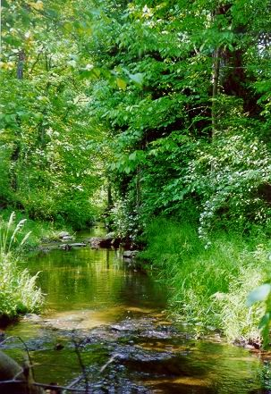
Please send comments to judith.cronauer@fairfaxcounty.gov

TABLE OF CONTENTS

I. INTRODUCTION……………………………………………………….

II. HOW COUNTY STORMWATER REQUIREMENTS
ARE ADOPTED…………………………………………………………

III. THE STORMWATER REQUIREMENTS………………………………

A. STORMWATER REQUIREMENTS REGARDING
QUANTITY OF STORMWATER RUNOFF…………………...

B. STORMWATER REQUIREMENTS REGARDING
QUALITY OF STORMWATER RUNOFF……………………..

C. STORMWATER OUTFALL REQUIREMENTS
(POTENTIAL IMPACTS TO RECEIVING SYSTEMS)……….

D. DRAINAGE DIVERSIONS……………………………………..

E. FLOODPLAINS…………………………………………………

IV. HOW THE COUNTY STORMWATER REQUIREMENTS ARE ENFORCED………………………………………………………………

FIGURES

Figure III-1. Extent of Review – Option 1...............................................
Figure III-2. Extent of Review – Option 2...............................................

APPENDICES

Appendix A. References
Appendix B. Glossary

CONTACT INFORMATION

Department of Public Works and Environmental Services
Land Development Services
12055 Government Center Parkway, Suite 444
Fairfax, Virginia 22035-5500

(703)324-1980 TTY 711

www.fairfaxcounty.gov/dpwes

